

School of Computer Science, UPES, Dehradun.

Lab 11

DevSecOps Lab

B.TECH. - V Semester

**Submitted to:**

Dr. Hitesh Kumar Sharma

**Submitted by:**

Name: Ishika Mehrotra

Batch: Devops B1

Sap Id: 500124411

Roll No.: R2142230281

**Lab Exercise 2– Terraform AWS Provider Configuration**

**Prerequisites: Terraform Installed: Make sure you have Terraform installed on your machine. Follow the official installation guide if needed.**

**Exercise Steps:**

**Step 1: Create a New Directory:**

Create a new directory for your Terraform configuration:

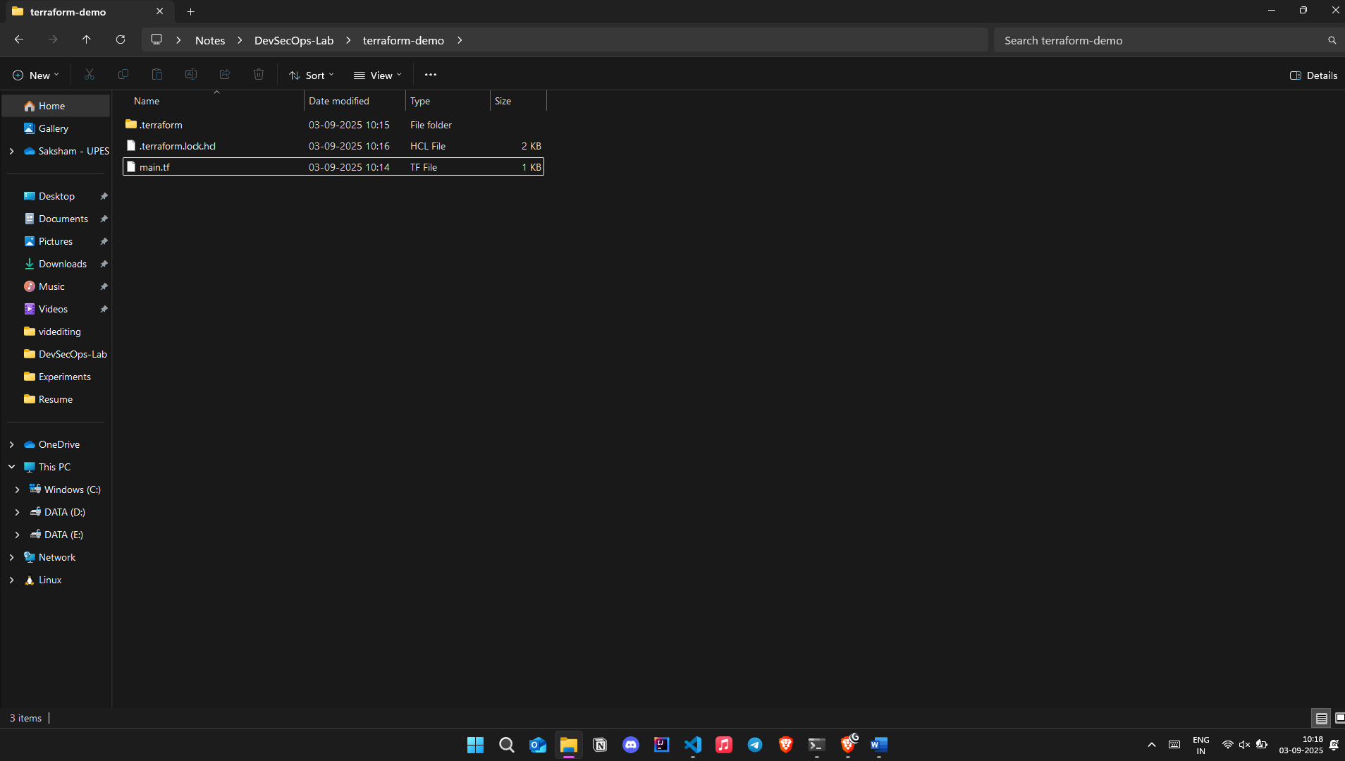

“**Terraform-Demo”**

**Step 2: Create Terraform Configuration File (main.tf):**

Create a file named main.tf with the following content:

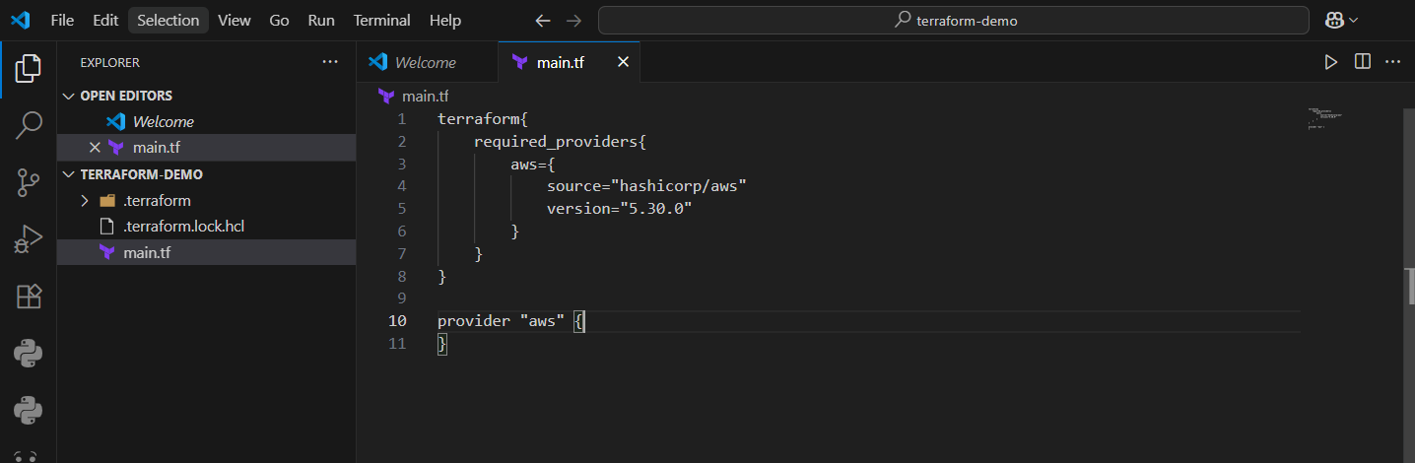

**Step 3: Initialize Terraform:**

Run the following command to initialize your Terraform working directory:

**terraform init**

